**Họ và tên : Lại Vĩnh Hào – MSSV : 21106511**

**Code :**

#include "stdio.h"

* Không có hình file -1d
* Không xuất được file và đọc file => câu 4 0d
* Tổng 6 -1 sai lưu đồ =5d

#include "string.h"

#include "time.h"

#include "conio.h"

#include "stdlib.h"

struct date{

int ngay;

int thang;

int nam;

};

struct SinhVien{

int id;

char ten[50];

char gioiTinh[5];

date ngaySinh;

float Toan;

float Hoa;

float Ly;

float diemTrungBinh;

char hocLuc[10];

int khuVuc;

int Nhom;

};

typedef SinhVien SV;

void nhapSinhVien(SV &sv);

void inSinhVien(SV sv);

void tinhDiemTrungBinh(SV *sv);

void xepLoai(SV &sv);

void capNhatSinhVien(SV &sv);

void nhapDanhSachSinhVien(SV ds[], int &n);

void xuatDanhSachSinhVien(SV ds[], int n);

void sapXepDanhSachSinhVienTheoDTB(SV ds[], int n);

void sapXepDanhSachSinhVienTheoTen(SV ds[], int n);

void xuatDanhSachSinhVienXepLoai(SV ds[], int n);

void xuatVaoFile1(SV ds[], int n);

void xuatVaoFile2(SV ds[], int n);

void nhapTuFile1(SV ds[], int &n);

void nhapTuFile2(SV ds[], int &n);

void xoaXuongDong(char x[]){

size_t len = strlen(x);

if(x[len-1]=='\n'){

x[len-1]='\0';

}

}

void nhapSinhVien(SV &sv){

printf("\nID : "); scanf("%d",&sv.id);

printf("\nKhu vuc: "); scanf("%d", &sv.khuVuc);

printf("\nNhom : "); scanf("%d",&sv.Nhom);

printf("\nTen: "); fflush(stdin); fgets(sv.ten, sizeof(sv.ten), stdin); xoaXuongDong(sv.ten);

printf("\nGioi tinh: "); fflush(stdin); fgets(sv.gioiTinh, sizeof(sv.gioiTinh), stdin); xoaXuongDong(sv.gioiTinh);

printf("\nNgay sinh"); scanf("%d%d%d", &sv.ngaySinh.ngay, &sv.ngaySinh.thang, &sv.ngaySinh.nam);

printf("\nDiem Toan: "); scanf("%f", &sv.Toan);

printf("\nDiem Ly: "); scanf("%f", &sv.Ly);

printf("\nDiem Hoa: "); scanf("%f", &sv.Hoa);

}

void inSinhVien(SV sv){

printf("%5d \t %20s \t %10s \t %2d/%d/%d \t %5d \t\t %5d \t %6.2f \t% 6.2f \t\t %6.2f \t %6.2f \t %5s ", sv.id, sv.ten, sv.gioiTinh, sv.ngaySinh.ngay, sv.ngaySinh.thang, sv.ngaySinh.nam, sv.khuVuc,sv.Nhom,sv.Toan, sv.Ly, sv.Hoa, sv.diemTrungBinh, sv.hocLuc);

printf("\n");

printf("------------------------------------------------------------------------------------------------------------------------------------------------------------------------------------");

}

void tinhDiemTrungBinh(SV *sv){

sv->diemTrungBinh = (sv->Toan+sv->Ly+sv->Hoa);

}

void xepLoai(SV &sv){

switch (sv.khuVuc){

case 1 :

switch (sv.Nhom){

case 1 :

if(sv.diemTrungBinh>=18){

strcpy(sv.hocLuc, "DAU");

}else {

strcpy(sv.hocLuc, "ROT");}

case 2 :

if(sv.diemTrungBinh>=17.5){

strcpy(sv.hocLuc, "DAU");

}else {

strcpy(sv.hocLuc, "ROT");}

case 3 :

if(sv.diemTrungBinh>=17){

strcpy(sv.hocLuc, "DAU");

}else {

strcpy(sv.hocLuc, "ROT");}

}

case 2 :

switch (sv.Nhom){

case 1 :

if(sv.diemTrungBinh>=17){

strcpy(sv.hocLuc, "DAU");

}else {

strcpy(sv.hocLuc, "ROT");}

case 2 :

if(sv.diemTrungBinh>=16.5){

strcpy(sv.hocLuc, "DAU");

}else {

strcpy(sv.hocLuc, "ROT");}

case 3 :

if(sv.diemTrungBinh>=16){

strcpy(sv.hocLuc, "DAU ");

}else {

strcpy(sv.hocLuc, "ROT"); }

}

case 3 :

switch (sv.Nhom){

case 1 :

if(sv.diemTrungBinh>=16){

strcpy(sv.hocLuc, "DAU");

}else {

strcpy(sv.hocLuc, "ROT");}

case 2 :

if(sv.diemTrungBinh>=15.5){

strcpy(sv.hocLuc, "DAU");

}else {

strcpy(sv.hocLuc, "ROT");}

case 3 :

if(sv.diemTrungBinh>=15){

strcpy(sv.hocLuc, "DAU");

}else {

strcpy(sv.hocLuc, "ROT");}

}

}

}

void sapXepDanhSachSinhVienTheoDTB(SV ds[], int n){

for(int i=0; i<n-1; i++){

for(int j=i+1; j<n; j++){

if(ds[i].diemTrungBinh<ds[j].diemTrungBinh){

SV temp;

temp = ds[i];

ds[i] = ds[j];

ds[j]=temp;

}

}

}

}

void capNhatSinhVien(SV &sv){

nhapSinhVien(sv);

tinhDiemTrungBinh(&sv);

xepLoai(sv);

}

void nhapDanhSachSinhVien(SV ds[], int &n){

do{

printf("\nNhap vao n:");

scanf("%d", &n);

}while(n<=0);

for(int i=0; i<n ; i++){

printf("\nNhap vao sinh vien thu %d: ", i);

capNhatSinhVien(ds[i]);

}

}

void xuatDanhSachSinhVien(SV ds[], int n){

printf("%5s \t %20s \t %10s \t %10s \t %6s \t %6s \t %6s \t %6s \t %6s \t %6s \t %5s ", "STT", "Ten", "Gioi Tinh", "Ngay Sinh","KhuVuc","Nhom", "TOAN", "Ly", "HOA", "Diem TLH", "XepLoai");

printf("\n");

printf("------------------------------------------------------------------------------------------------------------------------------------------------------------------------------------\n");

for(int i=0; i<n ; i++){

inSinhVien(ds[i]);

printf("\n");

}

}

void xuatDanhSachSinhVienXepLoai(SV ds[], int n, char xepLoai[]){

printf("%5s \t %20s \t %10s \t %10s \t %6s \t %6s \t %6s \t %6s \t %6s \t %6s \t %5s ", "STT", "Ten", "Gioi Tinh", "Ngay Sinh","KhuVuc","Nhom", "TOAN", "Ly", "HOA", "Diem TLH", "XepLoai");

printf("\n");

printf("------------------------------------------------------------------------------------------------------------------------------------------------------------------------------------\n");

for(int i=0; i<n ; i++){

if (strcmp(strupr(ds[i].hocLuc),strupr(xepLoai))==0){

inSinhVien(ds[i]);

printf("\n");

}

}

}

//void xuatVaoFile1(SV ds[], int n){



//



// FILE *f;

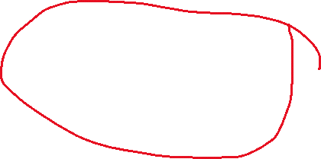

// f = fopen("D:\BaitapC\dau.txt", "w");

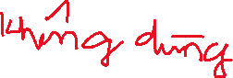

// if(f==NULL){

// printf("\nLoi moi file de ghi!");

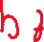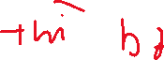

// }else {

// for(int i=0; i<n; i++){

// if (strcmp(ds[i].hocLuc,"DAU")==0){

//

// fprintf(f,"%5d \t %20s \t %10s \t %2d/%d/%d \t %5d \t\t %5d \t %6.2f \t% 6.2f \t\t %6.2f \t %6.2f \t %5s \n\n", ds[i].id, ds[i].ten, ds[i].gioiTinh, ds[i].ngaySinh.ngay, ds[i].ngaySinh.thang, ds[i].ngaySinh.nam, ds[i].khuVuc, ds[i].Nhom, ds[i].Toan, ds[i].Ly, ds[i].Hoa, ds[i].diemTrungBinh, ds[i].hocLuc);

// }

// }

// }

// fclose(f);

//

//}

void xuatVaoFile2(SV ds[], int n){

FILE *f;

f = fopen("D:\BaitapC\rot.txt", "wb");

if(f==NULL){

printf("\nLoi moi file de ghi!");

}else {

for(int i=0; i<n; i++){

if (strcmp(ds[i].hocLuc,"ROT")==0){

fprintf(f,"%5d \t %20s \t %10s \t %2d/%d/%d \t %5d \t\t %5d \t %6.2f \t% 6.2f \t\t %6.2f \t %6.2f \t %5s \n\n", ds[i].id, ds[i].ten, ds[i].gioiTinh, ds[i].ngaySinh.ngay, ds[i].ngaySinh.thang, ds[i].ngaySinh.nam, ds[i].khuVuc, ds[i].Nhom, ds[i].Toan, ds[i].Ly, ds[i].Hoa, ds[i].diemTrungBinh, ds[i].hocLuc);

}

}

fclose(f);

}

}

//void nhapTuFile1(SV ds[], int &n){

//

//

// FILE *f;

// f = fopen("D:\BaitapC\dau.txt", "rb");

// if(f==NULL){

// printf("\nLoi moi file de doc!");

// return;

// }

// fread(&n, sizeof(n), 1, f);

// for(int i=0; i<n; i++){

// if ((strcmp(ds[i].hocLuc,"DAU")==0)&& (strcmp(ds[i].gioiTinh,"Nam")==0))

// fread(f,"%5d \t %20s \t %10s \t %2d/%d/%d \t %5d \t\t %5d \t %6.2f \t% 6.2f \t\t %6.2f \t %6.2f \t %5s \n\n", ds[i].id, ds[i].ten, ds[i].gioiTinh, ds[i].ngaySinh.ngay, ds[i].ngaySinh.thang, ds[i].ngaySinh.nam, ds[i].khuVuc, ds[i].Nhom, ds[i].Toan, ds[i].Ly, ds[i].Hoa, ds[i].diemTrungBinh, ds[i].hocLuc);

// }

// fclose(f);

//}

//void nhapTuFile2(SV ds[], int &n){

//

//

// FILE *f;

// f = fopen("D:\BaitapC\dau.txt", "rb");

// if(f==NULL){

// printf("\nLoi moi file de doc!");

// return;

// }

// fread(&n, sizeof(n), 1, f);

// for(int i=0; i<n; i++){

// if ((strcmp(ds[i].hocLuc,"ROT")==0)&& (strcmp(ds[i].gioiTinh,"Nu")==0)

// fread(f,"%5d \t %20s \t %10s \t %2d/%d/%d \t %5d \t\t %5d \t %6.2f \t% 6.2f \t\t %6.2f \t %6.2f \t %5s \n\n", ds[i].id, ds[i].ten, ds[i].gioiTinh, ds[i].ngaySinh.ngay, ds[i].ngaySinh.thang, ds[i].ngaySinh.nam, ds[i].khuVuc, ds[i].Nhom, ds[i].Toan, ds[i].Ly, ds[i].Hoa, ds[i].diemTrungBinh, ds[i].hocLuc);

// }

// fclose(f);

//}

int main(){

SV ds[100];char xepLoai[20];

int n;

nhapDanhSachSinhVien(ds, n);

printf (" \n\t\t\t\t\t\tCAU 1 : XUAT DANH SACH VUA NHAP !\n\n\n");

xuatDanhSachSinhVien(ds, n);

printf (" \n\t\t\t\t\t\tCAU 2 : XUAT DANH SACH VUA NHAP THEO CACH GIAM DAN !\n\n\n");

sapXepDanhSachSinhVienTheoDTB(ds, n);

xuatDanhSachSinhVien(ds, n);

printf (" \n\t\t\t\t\t\tCAU 3 : XUAT DANH SACH TRUNG TUYEN !!! \n\n\n");

printf("\nNhap xep loai can hien thi: "); fflush(stdin); fgets(xepLoai, sizeof(xepLoai), stdin); xoaXuongDong(xepLoai);

xuatDanhSachSinhVienXepLoai(ds, n, xepLoai);

//

printf (" \n\t\t\t\t\t\tCAU 4 : XUAT FILE DAU !!! \n\n\n");

// xuatVaoFile1(ds, n);

printf (" \n\t\t\t\t\t\tCAU 4 : XUAT FILE ROT !!! \n\n\n");

// xuatVaoFile2(ds, n);

printf (" \n\t\t\t\t\t\tCAU 4 : NHAP FILE DAU - NAM !!! \n\n\n");

// nhapTuFile1(ds, n);

printf (" \n\t\t\t\t\t\tCAU 4 : NHAP FILE ROT - NU !!! \n\n\n");

// nhapTuFile2(ds, n);

}

**EXE :**

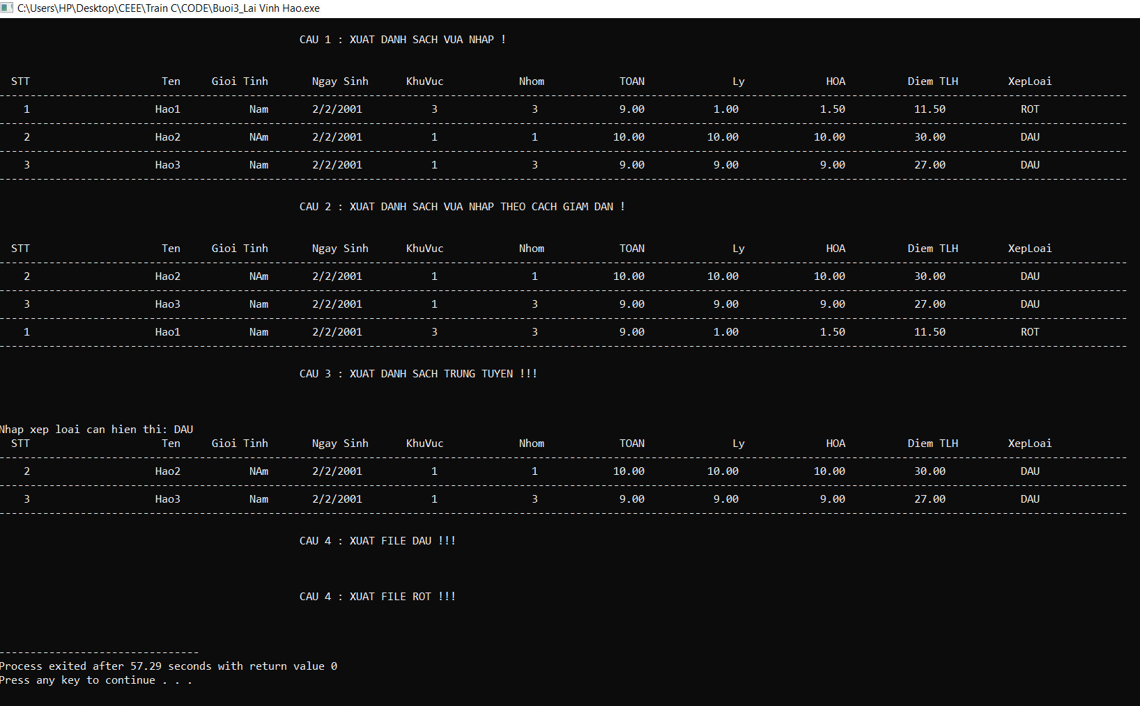

**Lưu đồ :**

**Câu 2-3:**



